Newspaper articles about Trooper Ernstsen, Utah Highway Patrol and SLPD, Intoxilyzer 8000

- KSL, Utah Highway Patrol troopers are watching for distracted and impaired drivers this summer
- Salt Lake Tribue, “Utah Highway Patrol discipline problems go beyond Lisa Steed”
- ACLU Files Suit to Stop Racial Profiling by Utah Highway Patrol
- Police shooting: Neighbors stunned to learn Salt Lake City victim was their ‘peaceful’ neighbor
- Shooting
- New York Times, “These Machines Can Put You in Jail. Don’t Trust Them” By Stacy Cowley and Jessica Silver-Greenberg, 2019
- KSL, Utah driver dies after being handcuffed; troopers cleared

- KSL, Utah Highway Patrol troopers are watching for distracted and impaired drivers this summer by Mike Stapley

SALT LAKE CITY — With summer in full swing, the Utah Highway Patrol is seeing more traffic, as well as an increase in violations that can impact public safety. Summer enforcement initiatives include identifying distracted and impaired drivers.

"When distracted driving laws were first written, we had no concept of what all the cellphone would become and how involved it is in people's lives today," said UHP Col. Michael Rapich. "The state Legislature has to balance personal liberty with public safety, but distraction is probably the most underreported contributor to vehicle crashes."

The agency's origins predate the necessity of Utah drivers being required to even have a driver's license — beginning with just two part-time officers, hired in 1925, to patrol Utah highways and enforce traffic laws.

By 1928, the agency employed five full-time officers and five years later, it was given the name it goes by today. A year later, the Utah Highway Patrol was given the responsibility to test applicants for Utah's new driver's license.

The state Legislature empowered the UHP with statewide law enforcement jurisdiction in 1935. And by 1940, more than 50 sworn officers were employed by the agency.

Today, according to Rapich, the UHP's original mission to patrol Utah's freeways and highways stands, but it has expanded to include providing security at the state Capitol and for the governor. In addition, the agency is part of the Utah Department of Public Safety with a commissioner that is part of the governor's cabinet.

"There are troopers that work outside of the Utah Highway Patrol; they work at the State Bureau of Investigations and also do statewide narcotics investigations. We have a statewide Major Crimes Unit that does death investigations on the highways, but also supports local law enforcement agencies with their investigations," said Rapich.

In rural Utah, the UHP supports local agencies and, according to Rapich, there are times when a trooper and a local sheriff's deputy may be the only law enforcement officers on duty for hundreds of square miles.

Public safety priority
Seat belt use in Utah is high, according to Rapich, but the fewer than 10% of Utahns who don't buckle up represent between 40-50% of highway fatalities.

He said every trooper is trained to identify impaired drivers, and the statewide agency makes one one out of every three DUI arrests in Utah, despite making up fewer than 10% of the total police officers on the roads at any given time.

Trooper Julio Roman, who has nearly four years with the UHP, was a police officer in North Carolina prior to moving to Utah. On a recent shift patrolling both directions of I-15 in Utah County, he responded to a citizen complaint of an illegally parked boat in Santaquin. Roman is typically a motor squad officer, patrolling on a motorcycle.

This particular day, however, he was in a marked Dodge Durango sport utility vehicle.

He would consistently predict throughout the day, simply observing a car ahead of or behind him, whether they were distracted or would pass us while speeding. And, distracted drivers, of which there are plenty, were consistently unaware enough of their surroundings while driving — not even noticing his fully marked police vehicle on the freeway.

"I've learned to identify several behaviors that tell me a driver isn't paying attention," Roman said. "They don't maintain their lane, they exit the freeway at the last second, some are visibly on their phone, a pattern of driving fast and then slow and, even the person that's driving too slowly all the time, is often using their phone."

Roman's cruiser was equipped with both radar (to detect the fastest vehicle ahead or behind) and a LiDAR hand-held gun to be able to lock onto specific vehicles while stopped — the proverbial speed trap.

While Roman intended to use LiDAR at some point, he was kept busy enough while driving that it wasn't necessary. Radar pinpoints a speed and troopers then visually identify the fastest moving vehicle and pace it, by matching speeds, to confirm they are the violator. Any vehicle immediately in front of or behind Roman's cruiser is easily identified as a speeder.

Roman wrote several speeding tickets, including for a motorcycle travelling at 114 mph. Roman first spotted the motorcyclist approaching quickly from far behind. He wagered whether the driver would spot him and slow down.

He moved one lane to the right, putting two lanes between him and the motorcyclist. It wasn't until Roman worked his way over as the motorcycle passed that the driver spotted us. According to Roman, motorcyclists often flee when they are caught driving excessively fast, so getting the license plate number was his priority.

This motorcyclist did stop and was ticketed. Due to past infractions, this man's license could be jeopardized by this new ticket when he goes to court.

The state Legislature has to balance personal liberty with public safety, but distraction is probably the most underreported contributor to vehicle crashes.
–UHP Col. Mike Rapich
In another instance, as Roman entered I-15 southbound, a Tesla car sped past other drivers in the right lane of the on-ramp. The driver failed to signal as he merged each time to reach the freeway.

Roman sped to catch up and radar clocked the driver at 87 mph in a 70-mph zone. A ticket was issued.

Throughout the day, many tickets were issued to drivers for using cellphones while driving and for not wearing a seat belt. In one instance, a grandmother taking her grandchildren to an appointment said she was in a hurry and forgot to buckle up.

Her driving record showed Roman that she frequently doesn't wear one. And, she was ticketed.

Roman also participated in two traffic slowdowns this day so that dangerous debris could be removed from I-15.

On the way to that citizen complaint about the boat, Roman pulled next to a speeding driver, who didn't notice him prior to a friendly honk or two, and simply motioned for the driver to slow down. The driver complied and the trooper continued on his way.

Spotting drivers under the influence
According Rapich, troopers who exhibit great proficiency for identifying and arresting impaired drivers are selected for the DUI enforcement squad that concentrates its overnight efforts throughout the Salt Lake Valley — away from the freeways.

In addition to the squad's efforts, which are concentrated around bars and restaurants, other troopers, on their normal patrols on I-80, I-15 and other highways, are also watching for impaired drivers. On a recent night shift, Cpl. Brock Ernstsen and at least one other trooper were patrolling downtown Salt Lake City.

As the night progressed, it was apparent that other agencies, including the Salt Lake City Police Department, were also concentrating manpower around areas with bars and nightclubs.

Ernstsen, who has been with UHP for more than eight years, was very familiar with the location of nearly every bar. Unfortunately, he could also point out the locations of many severe auto accidents and arrests associated with extreme DUI, including cases where sober people had been in the vehicles and could have driven instead, he said.

Just like Roman, Ernstsen has also learned to identify the behaviors that lead him to suspect someone may be impaired. Interestingly, they're almost identical to those associated with distracted driving. In addition, though, impaired drivers often drive without their lights on or the wrong way on a road.

As reaction times are slowed by alcohol or drug use, drivers will also often drive too quickly and/or stop suddenly, or drive and stop too slowly altogether. The first driver pulled over that evening had stopped far into the crosswalk for two consecutive red lights, setting off red flags for Ernstsen.

The driver admitted to having had a beer or two at a basketball game at the Delta Center earlier that night. Ernstsen spoke to the driver and conducted the first field sobriety test while the driver remained seated in his vehicle — asking the driver to follow his finger with only his eyes.

What many may not know is that troopers aren't simply watching to see if a driver can or cannot follow these simple instructions. Alcohol impairment will also cause involuntary spasms of the eyes that are noticable. Various drugs can cause pupils to dilate and the whites of the eyes to be red.

To an untrained eye, the driver appeared to struggle with some of the several field sobriety tests he was asked to perform after stepping out of his vehicle. The driver was not, however, impaired, as a breathalyzer test confirmed.

A driver believed to have been driving under the influence completes field sobriety tests conducted by Utah Highway Patrol Cpl. Brock Ernstsen in Salt Lake City July 14. This driver was not impaired.
A driver believed to have been driving under the influence completes field sobriety tests conducted by Utah Highway Patrol Cpl. Brock Ernstsen in Salt Lake City July 14. This driver was not impaired. (Photo: Mike Stapley)

Ernstsen explained that part of the reason for drivers being subjected to so many different field tests is that some are more naturally proficient than others at some tasks. This particular driver may not be very coordinated, but he wasn't impaired.

UHP uses field sobriety tests created by the National Highway Traffic Safety Administration. The tests are more varied and more time consuming than those typically seen on TV and in movies. Breathalyzer tests can be performed in the field and blood draws, voluntarily or by execution of a warrant, can be done following arrest to further validate the field sobriety tests.

While a trooper pulling over a driver for a speeding violation may only rely on the automatic use of his dash camera to record events, it was common for Ernstsen to manually engage the camera and begin speaking to further document his reasons for pulling over a vehicle in the first place.

As he approached an intersection, a car in the left turn lane next to us was sitting partly into the intersection on a green arrow and not proceeding. Ernstsen pulled to the left behind the car as it finally pulled away and the car then proceeded to start and stop while driving slowly.

After pulling the vehicle over and speaking to the driver, it turned out the tourists from Las Vegas were not impaired but simply lost and trying to find the garage entrance to their hotel.

Another driver, in a convertible, pulled away from a stoplight erratically and quickly and seemed distracted by the car next to him. As Ernstsen hit his flashing lights to pull the driver over, the car immediately swerved across several lanes of traffic before stopping on the right shoulder.

Despite the driver seeming fidgety and nervous, the interactions he had with the driver convinced Ernstsen the driver was only showing off for his friends in the other car and was not impaired. The driver received a warning for careless driving.

At approximately 1 a.m. Ernstsen saw a driver plow over a concrete median separating two turn lanes. After stopping briefly to check his car for damage, the driver proceeded at 11 mph over the speed limit.

Following a stop and field sobriety tests, the driver was arrested for suspicion of impaired driving. A backup trooper had arrived and the vehicle was searched. In addition to an open container of alcohol placed on the floor of the back seat, three vials of a white, waxy substance were found in the glove compartment.

Troopers tested that waxy substance and it proved positive for THC, the active ingredient in marijuana. Troopers explained that these more concentrated forms of THC can impair drivers more severely than smoked marijuana and every bit as much as alcohol.

Another 30 minutes or so was spent reading the suspect his Miranda rights and issuing the various traffic citations warranted. We also waited for a tow truck to impound the Mercedes. The driver was asked whether he'd voluntarily agree to a blood draw to confirm his level of impairment.

The driver refused and Ernstsen was able to request a search warrant for the blood draw from his vehicle's computer. The driver was then taken to the UHP offices in Murray.

Utah Highway Patrol Cpl. Brock Ernstsen books evidence for a suspected DUI arrest on an overnight shift in Salt Lake City earlier this month.
Utah Highway Patrol Cpl. Brock Ernstsen books evidence for a suspected DUI arrest on an overnight shift in Salt Lake City earlier this month. (Photo: Mike Stapley)
After the warrant was approved — a judge is always on call — Ernstsen performed the blood draw. Another trooper witnessed it and then all evidence was booked, including two vials of the driver's blood.

The driver then agreed to an interview by Ernstsen. It would be another nearly two hours before the man was booked into the Salt Lake County Jail.

At least six other drivers were arrested that hursday night and Friday morning for suspicion of impaired driving by the UHP DUI squad alone.

"If there was a way for me to remain on the street while another trooper handled evidence and booked a driver into jail, I have no doubt, unfortunately, that I could get many more impaired drivers off the road each night than I can, as is," declared Ernstsen.

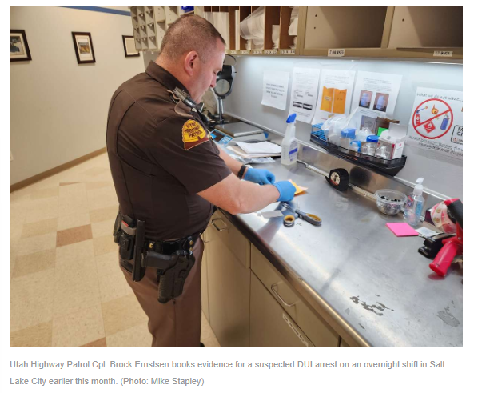

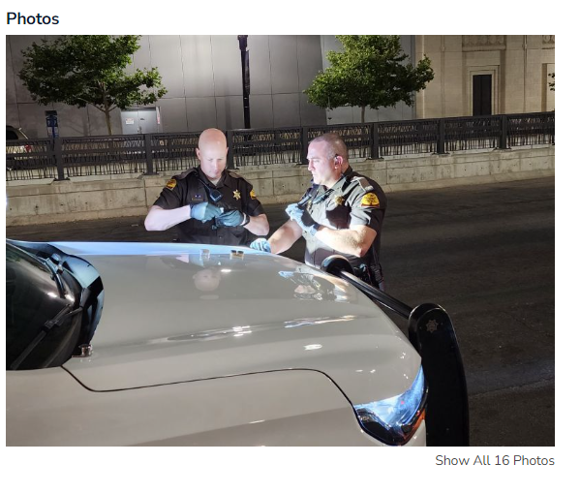

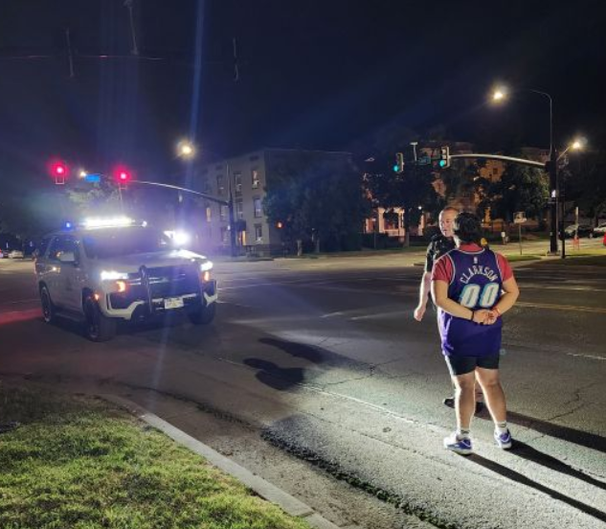

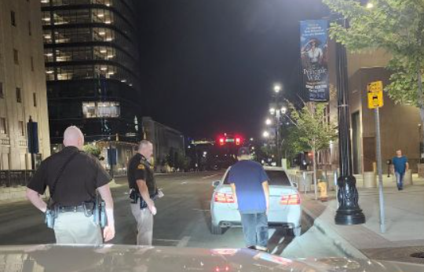

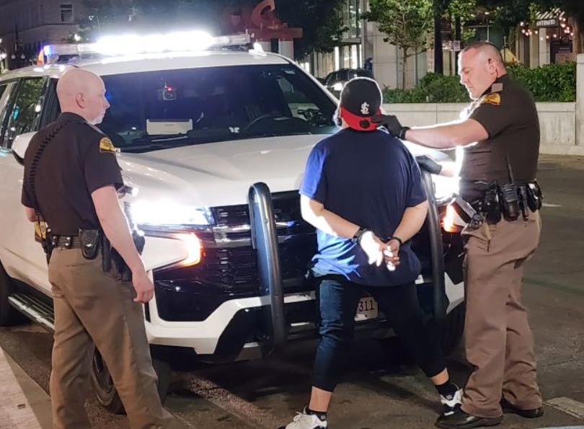

- Salt Lake Tribue, “Utah Highway Patrol discipline problems go beyond Lisa Steed”

As the case of a former UHP Trooper of the Year suspected of falsifying arrest reports and lying on the witness stand grabs headlines, The Tribune reveals wider problems in how UHP handles accusations of misconduct among its ranks.

Some might call it burglary or, at the least, trespassing.
But no criminal charges were filed against two Utah Highway Patrol sergeants who, in 2008, forced their way into a locked office at the state police academy to alter their timecards. And an internal investigation purportedly resulted in unequal punishment of the two officers.
Cody N. Wilder was demoted and his wages were reduced, but Gary Caldwell received a much lighter punishment: a 40-hour suspension.

"To this day, to know how Gary was treated versus how I was treated is frustrating," Wilder said in a recent interview.
While the case of Cpl. Lisa Steed, the one-time Trooper of the Year who is suspected of falsifying arrest reports and lying on the witness stand, has grabbed headlines, an investigation by The Salt Lake Tribune revealed wider problems in how UHP investigates and adjudicates accusations of misconduct among its 425 troopers — a number that puts it neck and neck with the Salt Lake City Police Department to be the largest police force in the state.
Former troopers and attorneys allege UHP is inconsistent with whom it disciplines and why. The agency also does not track citizen complaints against troopers and any outcomes the same way as many police departments in Utah and across the country do. And when citizens do file complaints, they are unlikely to learn what happened to the accused troopers.
A clause in UHP policy even gives top brass at the Utah Department of Public Safety (DPS) the authority to quash investigations of the most serious kinds of misconduct.
Administrators at DPS, to which UHP belongs, and UHP declined requests for interviews to discuss The Tribune's findings, but did respond in writing to some specific issues. DPS pointed out all of its policies are vetted by a corporation called Lexipol specializing in helping police departments manage risk. DPS wrote that it is policy to address all complaints.

"The Utah Highway Patrol is committed to maintaining the integrity of our department and accountability to the public," a DPS statement said. "Although no system is perfect, we take all complaints of misconduct very seriously and strive to address every issue in an unbiased, professional, and timely manner."
—
A bad search • On the night of April 20, 2011, Colorado resident Jeffrey Lawrence was driving to Las Vegas. He ran out of gas on Interstate 70 near Green River. What happened next cost the state $40,000 — the amount it paid Lawrence in a settlement.
UHP Cpl. Shawn Alton stopped behind Lawrence's Chevy Suburban and the cargo trailer he was towing. Alton began questioning Lawrence, including asking if the driver had drugs, weapons or large amounts of cash, according to court records. Lawrence said no and denied Alton's request to search the SUV and trailer.
Soon another state trooper, Gary Riches, and Emery County sheriff's Deputy Clayton Bell arrived. They and Alton continued questioning Lawrence, according to court papers, and eventually obtained a warrant to search the SUV and trailer as Lawrence and the vehicles remained on the side of the freeway.
The officers found 1 to 2 grams of marijuana and the pain reliever hydrocodone. Lawrence had prescriptions for both. But the Emery County Attorney's Office still charged Lawrence with a felony count of drug possession and three misdemeanors.

The charges were dismissed after it was learned that Alton entered false information on the search warrant application, according to court records. Alton claimed he had spoken to the county prosecutor, who approved asking the judge for the warrant, Lawrence's federal lawsuit claimed. In fact, the prosecutor had told Alton he did not yet have probable cause for a search warrant. Lawrence's attorney, Greg Stevens, said Alton claimed the electronic form he completed automatically filled in a section stating the prosecutor approved.
UHP paid Lawrence the $40,000 to settle his federal lawsuit alleging an illegal search, but there's another issue for Lawrence: What happened to his complaint against Alton?
UHP allows citizens to file complaints against troopers through its website or in person at any UHP office around the state or over the telephone.
If Alton worked for the Salt Lake City Police Department, for example, city policy says Lawrence would have been entitled to know if his complaint against Alton was sustained. For complaints against troopers of the Wyoming Highway Patrol, the complainant learns the outcome and, typically, receives a letter from a supervisor explaining why the accusation was sustained or not, said Maj. Perry Jones.
But from UHP, Lawrence has received only a two-paragraph letter from Maj. Mike Rapich.
"Appropriate action has been taken to address the concerns outlined in your letter dated Sept. 17, 2011," Rapich wrote.

The charges were dismissed after it was learned that Alton entered false information on the search warrant application, according to court records. Alton claimed he had spoken to the county prosecutor, who approved asking the judge for the warrant, Lawrence's federal lawsuit claimed. In fact, the prosecutor had told Alton he did not yet have probable cause for a search warrant. Lawrence's attorney, Greg Stevens, said Alton claimed the electronic form he completed automatically filled in a section stating the prosecutor approved.
UHP paid Lawrence the $40,000 to settle his federal lawsuit alleging an illegal search, but there's another issue for Lawrence: What happened to his complaint against Alton?
UHP allows citizens to file complaints against troopers through its website or in person at any UHP office around the state or over the telephone.
If Alton worked for the Salt Lake City Police Department, for example, city policy says Lawrence would have been entitled to know if his complaint against Alton was sustained. For complaints against troopers of the Wyoming Highway Patrol, the complainant learns the outcome and, typically, receives a letter from a supervisor explaining why the accusation was sustained or not, said Maj. Perry Jones.
But from UHP, Lawrence has received only a two-paragraph letter from Maj. Mike Rapich.
"Appropriate action has been taken to address the concerns outlined in your letter dated Sept. 17, 2011," Rapich wrote.

- ACLU Files Suit to Stop Racial Profiling by Utah Highway Patrol

SALT LAKE CITY,UT -- According to a story in today's Salt Lake Tribune, the ACLU has filed a lawsuit on behalf of an Arkansas writer against the Utah Highway Patrol for allegedly targeting ethnic-minority drivers on the state's roads.

"The [Utah Department of Public Safety] has a policy and practice of targeting certain individuals based principally on their perceived race or ethnicity, pulling them over for frivolous or nonexistent moving or equipment violations, and then subjecting them to unlawful detentions and searches," charges the lawsuit filed Tuesday in U.S. District Court. The full complaint is available at: http://www.acluutah.org/Kangcomplaint.htm.

According to the Tribune, Mani Kang, 24, a recent college graduate born in India, was traveling through southeastern Utah last summer on a tour of canyon country. He said he was driving north of Bluff on his way home from California -- staying in his lane, moving at the speed limit in a car with proper plates and registration stickers -- when he noticed a Utah Highway Patrol trooper following close behind. Kang says the patrolman tailed him for miles, even shadowing him as he stopped for gas. According to the ACLU, when Kang noticed the trooper inspecting his car, the gas station clerk warned him that the patrolman would "be waiting for you somewhere up the road. ... Anyone that doesn't seem from around here, he goes after ... especially if they're persons of color."

The Tribune reported that finally, about 10 miles north of Blanding, Trooper James E. Curtis pulled Kang over. For approximately the next 45 minutes, Kang waited in his car. Later, a second law enforcement officer arrived and the pair discussed Kang. In a videotape recorded inside Curtis' patrol car, Curtis explains why he was following Kang. "He was doing about 60 [miles per hour] back there by Blanding," Curtis said. "As he was passing, he gave me a kind of odd look. . . . Maybe he's legit. I don't know." The perception that Kang had given Curtis an "odd look" had more to do with Kang's skin color than his demeanor, contended attorney Stephen Clark of the Utah chapter of the American Civil Liberties Union [ACLU], who filed the federal civil-rights suit for Kang. But Utah Highway Patrol spokesman Lt. Chris Kramer claimed the traffic stop had nothing to do with race. Curtis noticed Kang was driving about 5 or 10 mph slower than the flow of traffic, that he seemed nervous, and that he stopped to buy only about $4 worth of gas -- a possible attempt to lose the trooper, Kramer said. "Troopers are trained not to look for one thing, but several things," Kramer said. "This is a drug interdiction area. All of those things taken together could be a sign of drug trafficking."

But the ACLU and others are not convinced. "Numerous law-abiding citizens, including plaintiff, have been unlawfully stopped, detained and searched, leaving them frightened, intimidated, humiliated and feeling like criminals, when they have done nothing to warrant such treatment," the lawsuit states. Kang, who was issued a warning for traveling in a passing lane after Curtis searched his car with Kang's permission, hopes the lawsuit will make a difference. He and his ACLU attorneys are asking U.S. District Judge Ted Stewart to prohibit the highway patrol from targeting minorities -- a practice known as profiling. Kang is also seeking unspecified compensatory and punitive damages and attorneys' fees. "I want to see a change, so that no one else has to go through this," Kang said, who returned to Utah for the filing of the lawsuit. "The tactics they use must be deemed unconstitutional."

use must be deemed unconstitutional." The Utah Highway Patrol is not alone in facing allegations of racial profiling -- law enforcement officers across the state and nation encounter the same criticism. A Utah state lawmaker recently proposed a bill that would require officers statewide to note the race of motorists they pull over. The measure passed the House during the 2000 Legislature but never made it to the Senate floor for a vote. (More information is available at: http://archive.aclu.org/news/1999/w122299a.html .)

When officers are required to track race on the citations they write, as they have been in Maryland and New Jersey, the results can be disturbing. Maryland state troopers knew their work was being monitored. Nevertheless, 73 percent of the cars subjected to stops and searches were driven by African-Americans, while only 14 percent of the people on the road were black. The 1995 Maryland study also found that 70 percent of the searches of cars driven by blacks turned up nothing.

Another study of traffic stops in a Florida county showed that nearly 80 percent of the drivers who had been stopped were black. Their stops lasted longer and they were twice as likely to be searched. Similar patterns have been reported in New Jersey. Many people of color in Utah have complained for years that they are targeted by police for traffic stops. Salt Lake City police and the Utah Highway Patrol are currently recording the race of drivers they stop to determine whether profiling is occurring. (More information is available at: http://archive.aclu.org/news/2000/w022700a.html.)

Kang "seeks to reaffirm what everyone in the United States has a right to expect," the lawsuit states: "That people of color may use the public highways without having to suffer the indignities of discriminatory treatment by government officials."

The lawsuit further alleged that, ". . . the DPS participates in a federally funded program sponsored by the United States Drug Enforcement Agency known as Operation Pipeline. The purpose of Operation Pipeline ostensibly is to remove drugs and weapons from the nation's highways. Operation Pipeline encourages officers to rely on minor or non-existent traffic violations that can be used as an excuse or `pretext' to stop motorists that seem `suspicious.' Once a stop has been made, officers engage in persistent questioning unrelated to the alleged underlying violation. Officers are trained to seek consent to search - which most unwary motorists give - in an effort to obviate the need for probable cause."

The ACLU alleges this tactic was used on Kang. The ACLU wrote U.S. Attorney General Janet Reno on June 4, 1999, urging her to institute various reforms in the DEA"s Pipeline program in order to prevent racial profiling. (See http://archive.aclu.org/congress/l060499a.html.) When the Justice Department entered into a consent decree with the New Jersey State Police in to address racial profiling concerns, the ACLU noted that the problem was not limited to one state and again pointed out the need for the problems in the Pipeline program to be addressed. (See http://archive.aclu.org/news/1999/w122999a.html.)

The ACLU has brought similar racial profiling lawsuits against state police drug interdiction activities in a number of other states including California ( http://archive.aclu.org/news/1999/n113099c.html), Oklahoma( http://archive.aclu.org/news/1999/n051899c.html), and Maryland( http://archive.aclu.org/news/2000/n030800b.html)."

V. Salt Lake Tribune, Police shooting: Neighbors stunned to learn Salt Lake City victim was their ‘peaceful’ neighbor
Shooting

Police shooting: Neighbors stunned to learn Salt Lake City victim was their ‘peaceful’ neighbor

Residents stunned to learn the man who allegedly attacked an officer with a shovel was their neighbor.

"Absolutely incomprehensible."

Those were the words James Dudley Barker's longtime friend used to describe allegations that Barker used a shovel to attack a Salt Lake City police officer with bone-breaking force before the officer shot Barker to death in a yard just one block from Barker's home.

"James was an incredibly peaceful person," said Summer Osburn, who became friends with Barker 20 years ago while they were students at Brigham Young University.

Several friends and neighbors of Barker, 42, gathered Friday at his home in the Avenues, where Barker had lived for several years and was known as an artistic nature-lover, musician and surfer, who volunteered at community arts events and quit his church basketball team because it was "too violent."

"He was one of [Jack] Kerouac's bright, burning roman candles," Osburn said.

| Courtesy Photo

James barker
| Courtesy Photo James barker

Barker's girlfriend said she had asked Barker to break up ice that had packed around a bus stop on the shaded north side of their home on Thursday afternoon. He evidently took the snow shovel and began walking through the neighborhood, near I Street and 2nd and 3rd avenues.

A neighbor called 911 about 3:30 p.m. to report a suspicious man was carrying a shovel and knocking on doors to seek work shoveling snow. The caller reportedly noted how little snow was on the ground, although icy patches remained on shaded sidewalks on Friday. The caller also said Barker matched the description of someone who on Wednesday was peering into car windows in the neighborhood, police said.

When the officer approached Barker on the porch of another house, a "verbal altercation" began, police said. Barker allegedly attacked the officer with the shovel, striking his arm and leg before the officer fired several times, police said.

Image from the body camera footage of the confrontation with James Dudley Barker.
Image from the body camera footage of the confrontation with James Dudley Barker.

The officer, whose name was not released, was taken to a hospital to treat fractures to his arm and foot. The officer was recovering at home on Friday. Police would not discuss how many shots were fired, how many struck Barker or where on his body he was wounded.

Detective Dennis McGowan confirmed the injured officer was equipped with a body camera, and that it was turned on at the time of the attack.

But police said the camera quit working at some point due to the violence of the attack.

The footage, released by police Friday night, shows Barker and the officer talking before Barker begins shouting and suddenly swings the shovel at the officer, which is when the footage ends.

The officer had told Barker that neighbors were suspicious of him. Police also claim Barker matched the description of someone who had been looking into cars the day before.

Richard Grow, who lives in the northwest corner of the Avenues, witnessed the final moments of the struggle between the officer and Barker.

Grow, 66, was driving south on I Street when, as he approached 2nd Avenue, he saw the two men leap off a front porch, one after the other. He said he is not sure if the officer was the first one off the porch or not; he initially thought they were two roommates fighting, and only later realized that one was a policeman.

By the time Grow pulled up, stopping his car about 40 feet from the fight, the two men were wrestling on the ground in front of the house.

"They wrestled on the ground for 10 to 15 seconds," Grow said. Then he saw the officer "reach around his side and pull out his gun and hold it up to the guy's chest and, bam, bam, bam ... Point blank against this man's chest."

Grow got out and asked the officer, who Grow thought looked haggard, if he needed any help.

"He just said 'get out of here,' " Grow said. He obeyed, but filled out a statement at police headquarters a few hours later.

During questioning, one thing the police kept asking him was if he could remember whether the officer or Barker was the first one off the porch. Grow can't.

"I did not know that. I wish I could tell them that," he said.

Grow also never saw a shovel, but added that anything involving the implement may have happened beforehand.

Neighbors said they were baffled that Barker would be considered suspicious by anyone living close by.

"He'd walk around. They'd be out doing the yard work, they'd be out here cooking," said neighbor Ron Lee, standing amid hanging mobiles and bric-a-brac decorating Barker's front porch, along with signs supporting Wasatch Community Gardens and Red Butte Gardens. "He wasn't a recluse at all. Anybody that's here should know who James is."

A search of court records found that Barker had no criminal record apart from a March 2014 guilty plea to a misdemeanor charge for failing to disclose his identity to a police officer. Prosecutors dropped a disorderly conduct charge in the same case.

Friends dismissed the suggestion that Barker would burglarize cars in the very neighborhood where he has lived for nearly a decade.

"This guy is regarded by a huge section of our arts community as a gentleman and one of the kindest people you'd ever meet," said Jonny Jemming, who volunteered alongside Barker at events and festivals. "He is a wonderful, wonderful man."

Kathie Chadbourne, who owns the Avenues Bistro on the same block as Barker's house, was well acquainted with Barker and occasionally provided used cooking oil to power Barker's bio-fuel car.

"I'm so sad," Chadbourne said tearfully, moments after discovering Barker was the subject in Thursday's shooting. "This is a good man. Oh, my God."

Kelly Schrock, who lives at the house where the shooting occurred but wasn't home at the time, said she said she was shocked to learn the man whose body was in her yard Thursday night was a neighbor she has seen many times.

"I've walked past their house hundreds of times," Schrock said of Barker and his girlfriend. "I've never seen them cause any harm or anything. They seem like perfectly nice neighbors."

Barker taught tennis lessons, did odd jobs for hire and worked as a musician, said Osburn and Heidi, Barker's girlfriend, who declined to release her last name.

"He was brilliant," Heidi said. "He was the most gentle, beautiful, non-violent soul. He hated conflict. I've never seen him hurt anyone. He loved people so much."

| Courtesy Photo

James barker
| Courtesy Photo James barker

Barker suffered some memory problems after a traumatic accident, Heidi said, "but he was doing very well." The possibility that Barker would instigate a fight with a police officer, much less break his bones, is "so far-fetched in my mind, I can't even perceive it," Heidi said.

Osburn recalled Barker's love of dancing and singing, particularly a song Barker made up about "Zoom, who comes from the moon, to deliver this special birthday message," which he sang to her son at his birthday three weeks ago.

"It doesn't make sense to any of us," Osburn said. "What does make sense is the pattern of police brutality. What does make sense is the reaction to minor calls with brutal, lethal force. Even if the officer were threatened with a shovel, why don't our officers know how to disable something like that? Why don't they have the skills taught in any common self-defense course that a woman takes to feel safe in the world?"

Schrock said the shooting was "disconcerting" and "tragic."

"I'm very sorry for James and his family, and also the officer and his family," she said.

The shooting was the first homicide in the state in the new year and one of two shootings by police on Thursday. A man in Syracuse suffered critical injuries when an officer shot him during a domestic violence call on Thursday night.

II. NYT article “These Machines Can Put You in Jail. Don’t Trust Them”
By Stacy Cowley and Jessica Silver-Greenberg, 2019

A million Americans a year are arrested for drunken driving, and most stops begin the same way: flashing blue lights in the rearview mirror, then a battery of tests that might include standing on one foot or reciting the alphabet.

What matters most, though, happens next. By the side of the road or at the police station, the drivers blow into a miniature science lab that estimates the concentration of alcohol in their blood. If the level is 0.08 or higher, they are all but certain to be convicted of a crime.

But those tests — a bedrock of the criminal justice system — are often unreliable, a New York Times investigation found. The devices, found in virtually every police station in America, generate skewed results with alarming frequency, even though they are marketed as precise to the third decimal place.

Judges in Massachusetts and New Jersey have thrown out more than 30,000 breath tests in the past 12 months alone, largely because of human errors and lax governmental oversight. Across the country, thousands of other tests also have been invalidated in recent years.

The machines are sensitive scientific instruments, and in many cases they haven’t been properly calibrated, yielding results that were at times 40 percent too high. Maintaining machines is up to police departments that sometimes have shoddy standards and lack expertise. In some cities, lab officials have used stale or home-brewed chemical solutions that warped results. In Massachusetts, officers used a machine with rats nesting inside.

Technical experts have found serious programming mistakes in the machines’ software. States have picked devices that their own experts didn’t trust and have disabled safeguards meant to ensure the tests’ accuracy.

The Times interviewed more than 100 lawyers, scientists, executives and police officers and reviewed tens of thousands of pages of court records, corporate filings, confidential emails and contracts. Together, they reveal the depth of a nationwide problem that has attracted only sporadic attention.
A county judge in Pennsylvania called it “extremely questionable” whether any of his state’s breath tests could withstand serious scrutiny. In response, local prosecutors stopped using them. In Florida, a panel of judges described their state’s instrument as a “magic black box” with “significant and continued anomalies.”
Even some industry veterans say the machines should not be de facto arbiters of guilt. “The tests were never meant to be used that way,” said John Fusco, who ran National Patent Analytical Systems, a maker of breath-testing devices.
Yet the tests have become all but unavoidable. Every state punishes drivers who refuse to take one when ordered by a police officer.
The consequences of the legal system’s reliance on these tests are far-reaching. People are wrongfully convicted based on dubious evidence. Hundreds were never notified that their cases were built on faulty tests.

And when flaws are discovered, the solution has been to discard the results — letting potentially dangerous drivers off the hook.
A man backed his car into an 83-year-old woman outside a liquor store and then failed field sobriety tests. Another man was stopped after vomiting out the window and veering “all over the road.” One more driver, with a suspended license, was pulled over and blew a 0.32 — a level of drunkenness that would leave most people unconscious.
All three were arrested and charged with driving drunk. All three had previous convictions for driving while intoxicated, according to police reports and court records. And all three were acquitted after Massachusetts was forced to throw out their breath tests — along with more than 36,000 others — in one of the largest exclusions of forensic evidence in American history.

The Deerfield River snakes through the woods of northwestern Massachusetts, and on a hot Sunday in July 2013 it was packed with rafters. Matthew Mottor arrived with more than a dozen friends and family members and two coolers of Blue Moon beer.

They spent hours tubing down the river and drinking before going ashore for a picnic. That’s when a drunk woman in the group caught the eye of a Massachusetts State Police trooper patrolling the area. The trooper, Steven Hean, told them to get their friend home. The party over, Mr. Mottor left his girlfriend and got a ride to his truck, a few miles upriver.

He pulled his gray Dodge Durango onto the winding road. He made it about 200 yards. Then he saw the flashing lights.

Trooper Hean wrote in a report that he stopped Mr. Mottor for driving 41 miles per hour in a 25 m.p.h. zone. Detecting “a strong odor” of liquor on Mr. Mottor’s breath, the trooper asked him to perform some field sobriety tests, including walking heel-to-toe.

Accidents years earlier had left Mr. Mottor with metal plates in his ankles and feet, court records show. “I explained to him that I’m not great at walking around on two feet on an everyday basis,” Mr. Mottor said. After passing two tests — reciting the alphabet and standing on one leg — he struggled to walk in a line. Trooper Hean brought out his breath tester.

Hand-held devices, like Trooper Hean’s Alco-Sensor IV, contain fuel cells that react to the alcohol in exhaled breaths and generate an electric current — the stronger the current, the higher the alcohol level. They are inexpensive and easy to maintain, but their results can be inconsistent. Older women sometimes have trouble producing enough breath to get the machines to work. Toothpaste, mouthwash and breath mints — even hand sanitizer and burping — may throw off the test results.

Tests from those portable machines are not admissible in court in most states (California is among the exceptions). But they often trigger an arrest, which leads to a test on another machine at the police station. That result determines whether someone is charged — and, often, whether they’re convicted.
By the side of River Road, Mr. Mottor blew a 0.13, far above the legal limit. That’s when the cuffs came out.

Attempts to prevent drunken driving predate the modern automobile.
In the late 19th century, Britain had outlawed being drunk while operating a “carriage, horse, cattle or steam engine.” In 1897, a London taxi driver named George Smith crashed his electric cab. He confessed to having had “two or three glasses of beer” and was fined 20 shillings. It is widely regarded as the first arrest for intoxicated driving.
Near the end of Prohibition, a biochemist invented a suitcase-sized machine with vials of chemicals and a balloon to blow into. Alcohol in the driver’s breath would trigger a reaction: the drunker the driver, the deeper the chemicals’ color. It was called the Drunkometer. But it was bulky and hard to use.

Two decades later, a police photographer and amateur chemist named Robert Borkenstein developed a similar but more portable machine. He named it the Breathalyzer.

Police departments around the country bought Mr. Borkenstein’s invention and versions developed by competitors. Then, in 1980, a fatal collision led to an overhaul of America’s drunken driving laws — and a sales boom for companies that made breath-testing devices.

Carime Lightner, 13, was walking to a church carnival in Fair Oaks, Calif., when a drunken driver slammed into her so hard she was knocked out of her shoes. The man had been arrested repeatedly for intoxicated driving.

Carime’s mother started Mothers Against Drunk Driving and launched one of the most effective citizen lobbying campaigns in history. States set stiffer penalties, including mandatory jail time in some cases, and made it illegal to drive with a blood-alcohol level above a designated mark.

The crackdown worked. In 1982, the year the National Highway Traffic Safety Administration began keeping records, some 21,000 people were killed in drunken-driving incidents. The number of deaths tumbled to around 10,500 in the most recent annual tally, even as the number of miles driven by Americans has nearly doubled.

In most of the country, the threshold for illegal drunkenness is 0.08 grams of alcohol per 100 milliliters of blood. The only way to measure that directly is to draw blood, which requires a warrant. Breath tests are simpler.

Testing machines can go for $10,000 or more, and some two dozen companies sell them in the United States. The biggest contracts, with state police crime labs, are worth millions.

A St. Louis company, Intoximeters, made the portable device used on Mr. Mottor. Dräger, a German company, owns the rights to the Breathalyzer name. CMI, based in Kentucky, is another industry leader.

“Our top priority is the quality and safety of our products,” said Brian Shaffer, a Dräger spokesman. “Our products provide the highest level of forensic and legal integrity.” He added, “Our advanced evidential breath alcohol testing instruments exceed the requirements of national and international regulatory agencies.”
- KSL, Utah driver dies after being handcuffed; troopers cleared

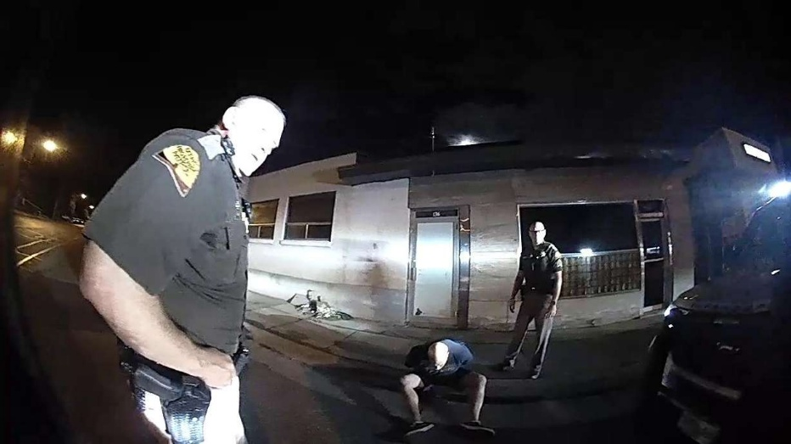
NB Trooper Ernstsen shown in photo

MURRAY — The Salt Lake County District Attorney's Office has determined several Utah Highway Patrol officers did nothing wrong during a traffic stop in which a man died after being placed in handcuffs.
On Aug. 12, 2022, Barry Spencer Young, 46, was pulled over for an equipment violation on his vehicle. Troopers questioning Young quickly suspected he may be under the influence of drugs.
In body camera video released Tuesday, a trooper asks Young to tilt his head back and close his eyes for 30 seconds. But Young, who has part of a straw in his mouth, keeps losing his balance.
"I can't do it," he tells the trooper.
"I think your internal clock sped up because you're on a stimulant (such as meth or cocaine)," the trooper tells Young. "I believe you have something in your system."
Young is then arrested and placed in handcuffs. At that point, another trooper asks him, "So, Barry, this is the time I really need you to be honest with me, OK? …For medical purposes, do you feel like I need to have an ambulance come check you out or anything like that?"
Young says he does not need medical attention, but the trooper asks dispatchers to send an ambulance, anyway. Moments later, as Young still has his wrists cuffed behind his back, he has a hard time maintaining his balance and troopers help him sit on the steps of a nearby porch; another trooper asks for the ambulance to be expedited.
At that point, the video released to the public is cut off.
According to the district attorney's office, "Medical personnel arrived at the scene and transported Mr. Young to the hospital where he later died from cocaine toxicity."
Young's obituary states he died "from complications of cardiac arrest." But family members also note, "somewhere along the way, addiction took hold and Barry battled it the rest of his life. He is free of that now, and capable of the potential he always had. But we will miss him so much."
Because of the circumstances, the Utah Highway Patrol invoked an officer-involved critical incident protocol investigation out of an abundance of caution. The district attorney's office determined "the incident did not fall within the statutory definition of an OICI. Nevertheless, the district attorney concluded that no wrongdoing had occurred and declined to file a criminal case against any law enforcement involved."

